**Time Series Forecasting**

# Project Report

**Problem:**

For this particular assignment, the data of different types of wine sales in the 20th century is to be analysed. Both of these data are from the same company but of different wines. As an analyst in the ABC Estate Wines, you are tasked to analyse and forecast Wine Sales in the 20th century.

1. **Read the data as an appropriate Time Series data and plot the data.**

We have received two separate data files for two separate wines, namely Rose and Sparkling.

Initially we import all the required libraries, such as numpy, pandas, seaborn and matplotlib.

Further to read the data we use the pd.read command to import the data. We then use the .head() and .tail() commands to view the first 5 and last 5 entries in the data set. This also gives us an idea of the time period the data covers.

To convert the data to a time series data, we introduce a date variable, and enter the start and end date of our data along with the frequency to create a date time index using the pd.date_range function. We then add this to our dataset as an additional column, convert it to date time format or else the system reads it as a string. We then set this column as the index of our dataset and we have our Time Series data. The same steps are carried out for both the datasets.

We then plot the data to understand how the spread of the data is over time.

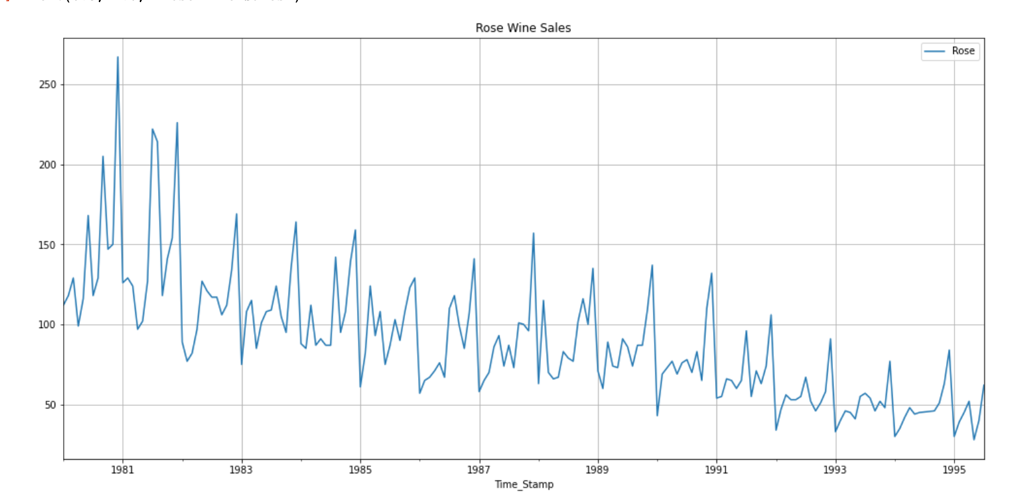

The first graph pertains to the Rose data set. From the graph it is evident that the wine sales have decline over time from 1980 to 1995, however there seems to be a cyclical trend wherein the there is a spike in wine sales to the end of the year, perhaps in the month of December. The highest sales appear to be in 1980 December around 260.

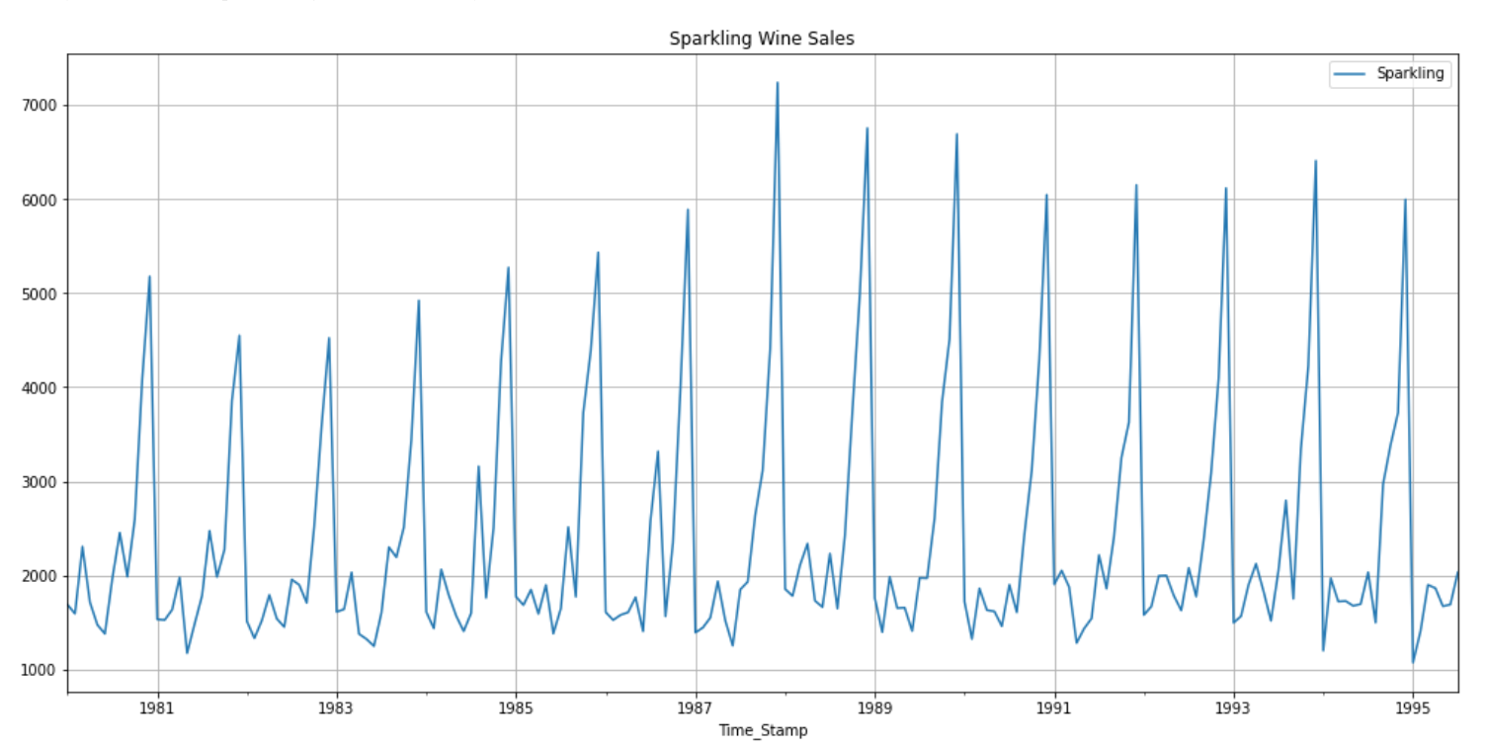

The second graph pertains to the Sparkling wine dataset. From the graph it is evident that wine sales have been more or less following the same pattern year on year. The trend seems to show a slight increase in the sales of wine. Similar to the Rose the data, we see the cyclical trend wherein there is a spike in sales in the month of December. The highest sales of Sparkling wine appear to be in 1988 December around 7100.

1. **Perform appropriate Exploratory Data Analysis to understand the data and also perform decomposition.**

For exploratory data analysis we will use both quantifiable and visual methods to glean as much information as we can from the data.

Rose

We use the info and describe function to see the details of the data set. The info function shows us there are 2 columns in the data set YearMonth and Rose which gives us the time element and Sales value for Rose. The describe function gives us the 5 point summary.

We use the isnull.sum function and note that the data has two missing values. We use the interpolate function to update the values. Since it’s a timeseries data we cannot have missing values or drop the missing values as that would imply that we have missing points in our dataset

We then plot the graph with the mean and the median to get an understanding of the fluctuation of data from these two measures of central tendency

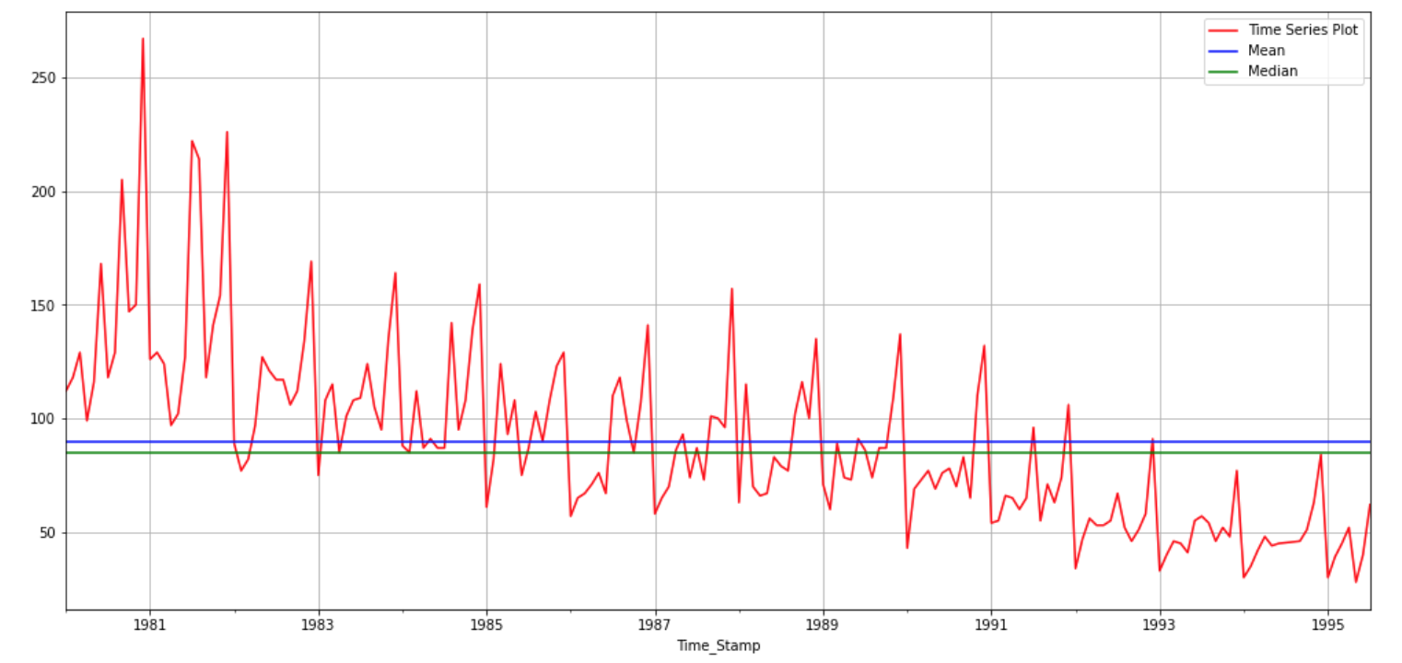

Boxplot - Yearly

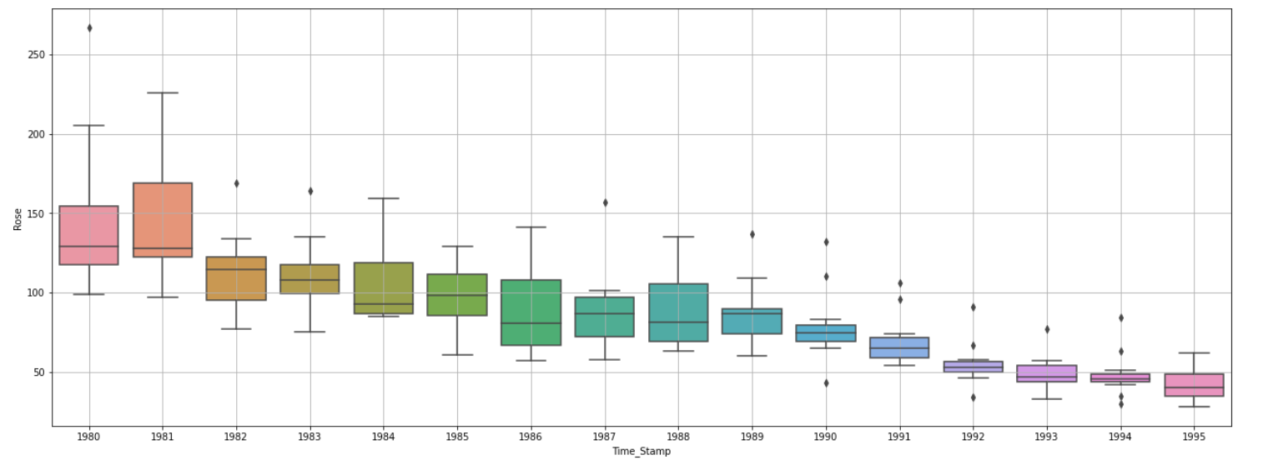

From the yearly box plot we can see that the trend across the years is decreasing. Also we can see that some years have outliers for Rose sales values

Boxplot - Monthly

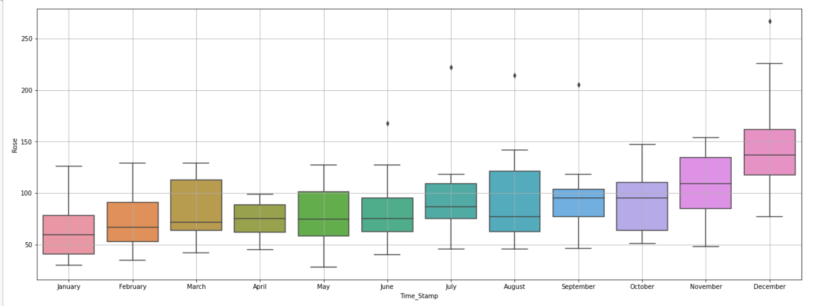

From the monthly plot we can see that sales are higher in the month of December as was evident in the time series plot as well. The monthly production has outliers present as well.

Month Plot

The month plot shows the variation of the sales for a month across years. We can observe that that for all the months the sales were high initially and as the time period extends the sales decline. December has the highest sales across all the months

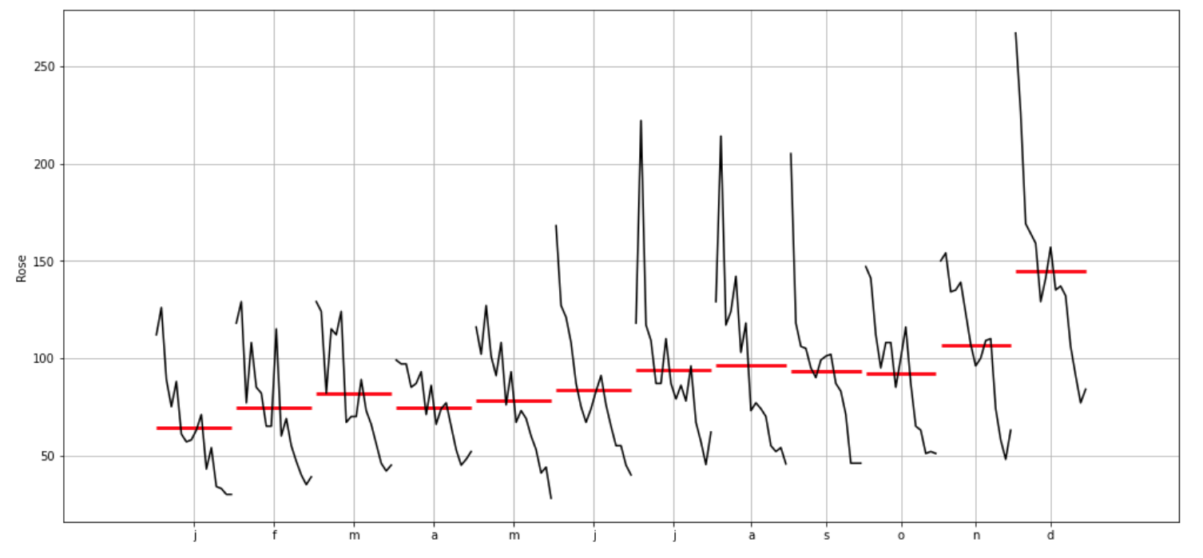

Line Plot

The line plot shows us the sales of Rose wine for each month respectively across all the years. We can observe that December has the highest sales. An overall trend can be seen of declining sales can also be observed across all the months

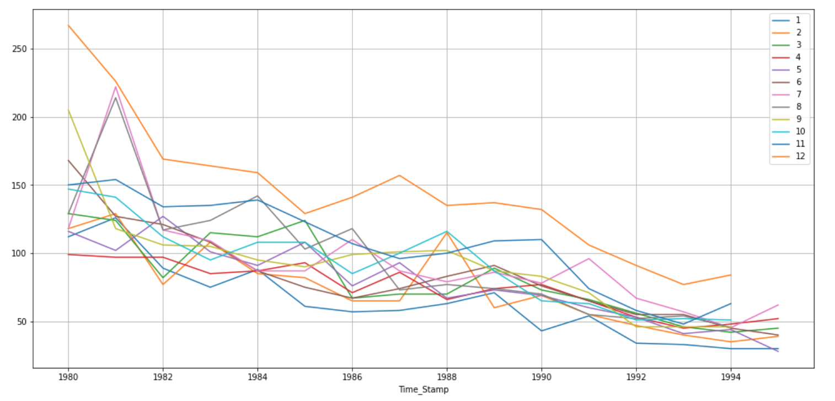

Month on Month Comparison

For Average rose sales we can observe that sales decline over time. There also seems to be a seasonal impact with sporadic spikes towards the end of the year. As observed before this could be attributed to the increased sales in December.

For percentage changes we can see that there major changes month on month. We can see spikes and troughs indicating multiple percentage changes across the time period

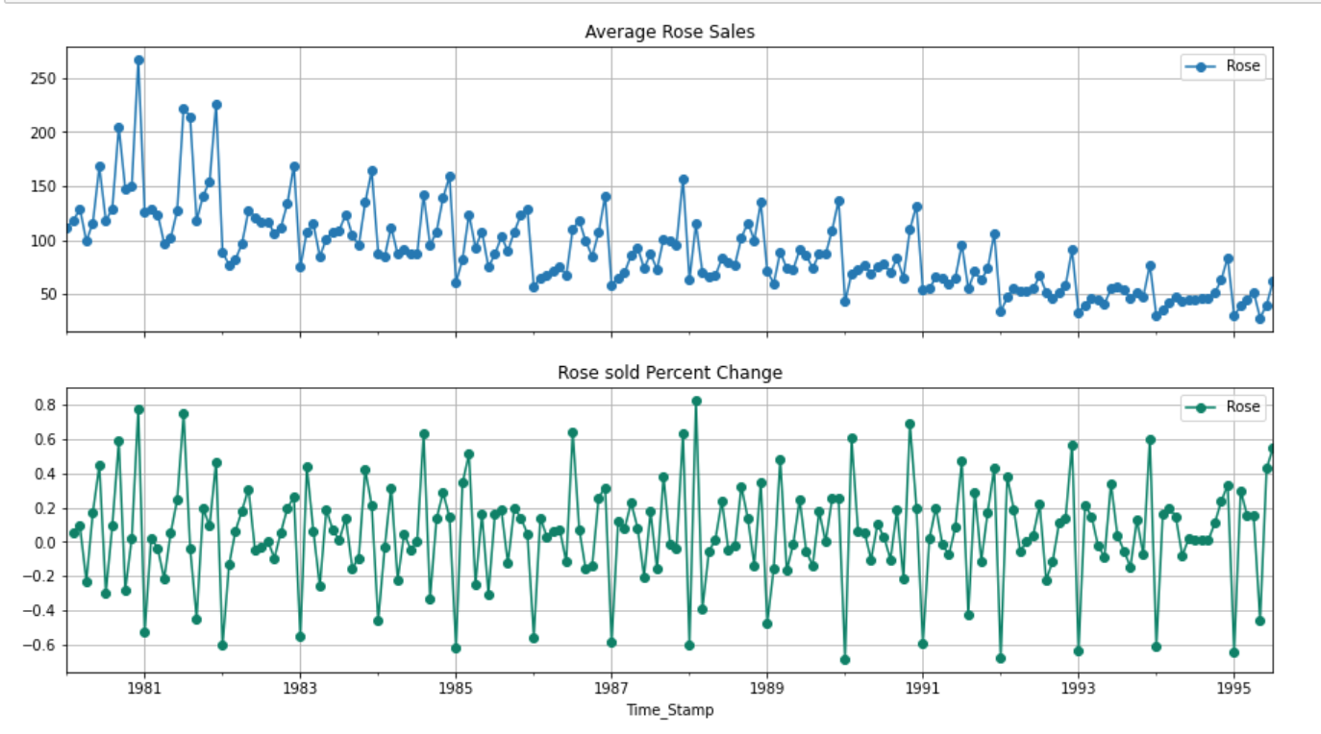

Sparkling

Similarly for Sparkling dataset 2 columns with 187 line items. YearMonth and Sparkling which gives us the time element and Sales value for Sparkling wine respectively. We get the 5 point summary.

There are no null values in the dataset. We use the interpolate function to update the values. Since it’s a timeseries data we cannot have missing values or drop the missing values as that would imply that we have missing points in our dataset

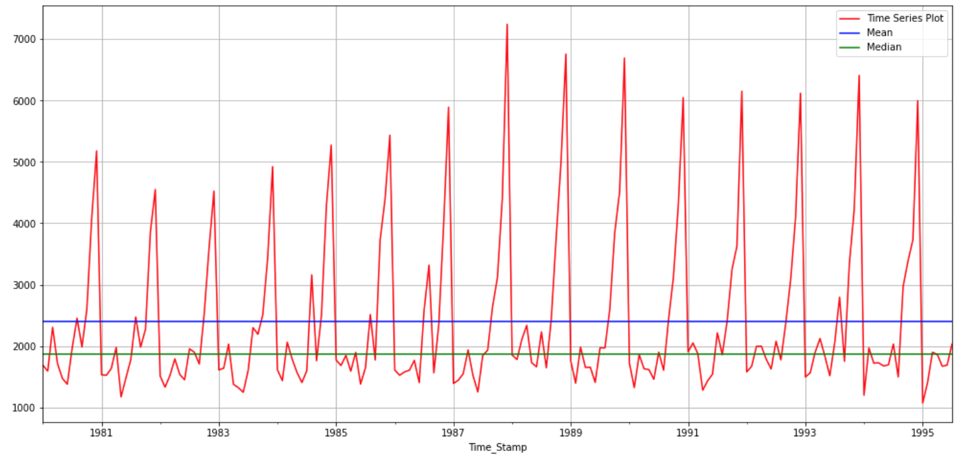

Boxplot – Yearly

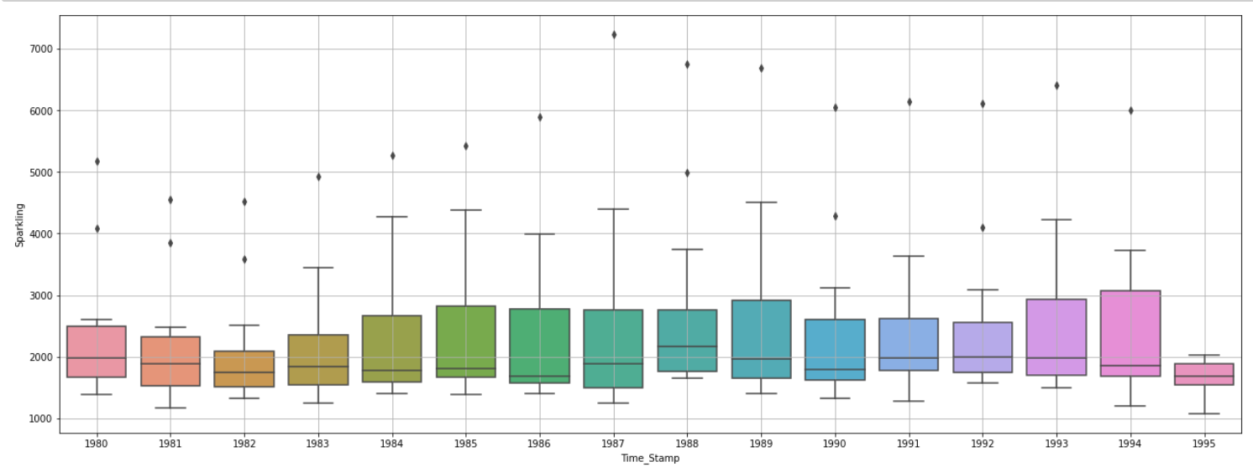

From the yearly boxplot we can see that there is no apparent trend in the dataset. The production seems mostly constant across all years. We can also see the that there are outliers present for all years.

Boxplot - Monthly

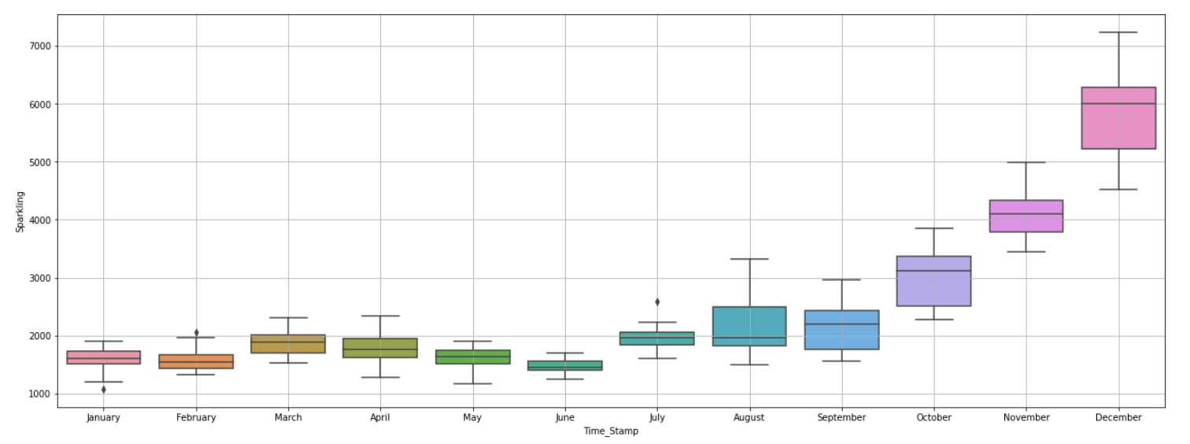

From the monthly boxplot we can see a trend across months. The sales are much higher towards the later month in the year. There are also outliers in some of the months

Month Plot

The month plot shows the variation of the sales for a month across years. We can observe that that for all the months the sales were low initially and as the time period extends the sales increase only to decline again. As the months progress the total sales increase with the highest sales in December.

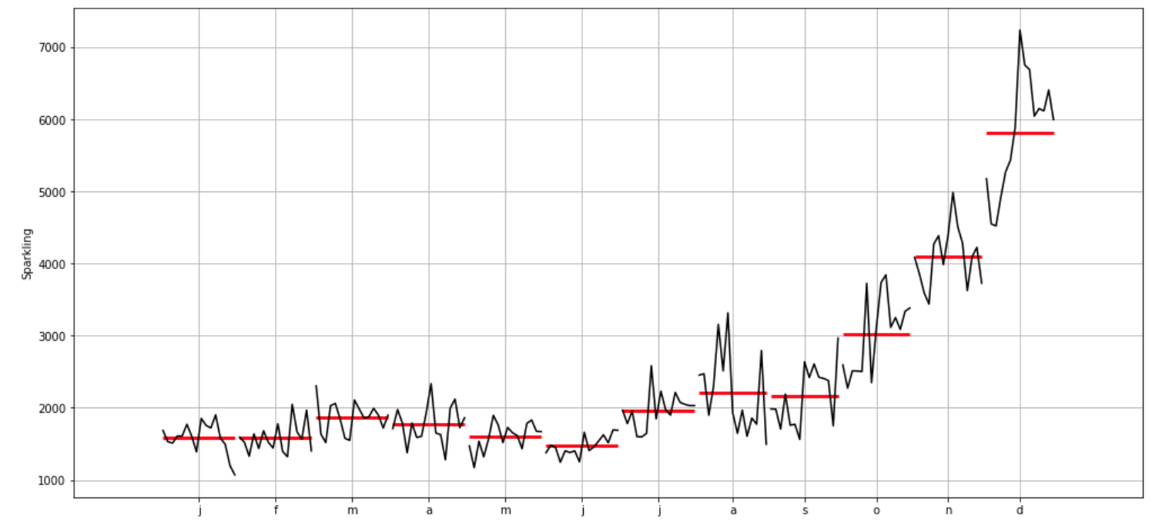

Line Plot

The line plot shows us the sales of Sparkling wine for each month respectively across all the years. We can observe that December has the highest sales followed by November and October indicating a seasonality that the wine sales are higher towards the end of the year. The rest of the months seem to follow a similar trend in terms of sales.

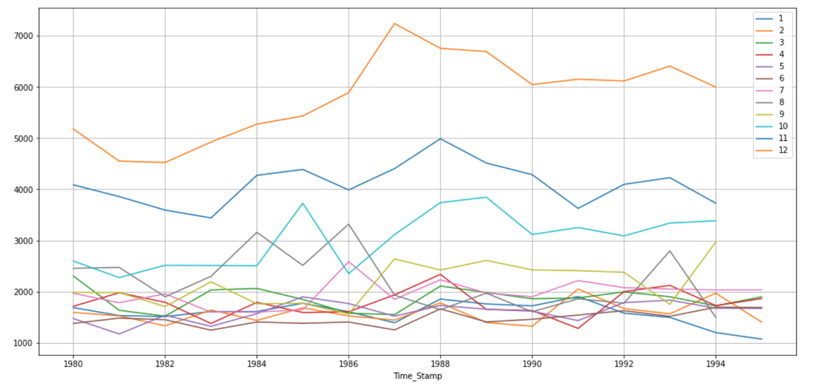

Month on Month comparison

For Average Sparkling wine sales we can observe that sales start low initially to further rise and then decline towards the end of our period. There also seems to be a seasonal impact with sporadic spikes towards the end of the year. As observed before this could be attributed to the increased sales in December.

For percentage changes we can see that there major changes month on month. We can see spikes and troughs indicating multiple percentage changes across the time period. There are extreme lows in the beginning of the year implying the drop in sales after the peak period of December

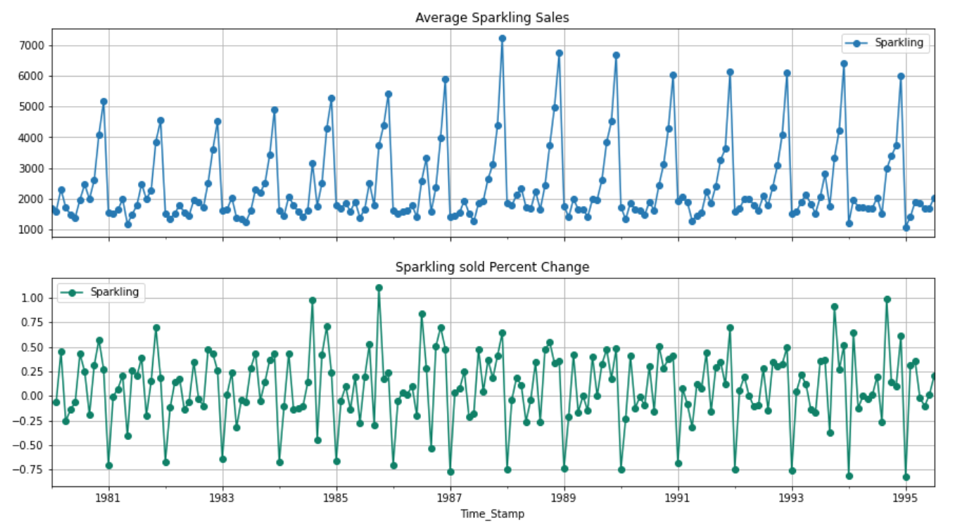

**Decomposition**

Decomposition involves thinking of a series as a combination of level, trend, seasonality, and noise components. Decomposition provides a useful abstract model for thinking about time series generally and for better understanding problems during time series analysis and forecasting. The components could combine either additively or multiplicatively. For both our models we have identified that they follow multiplicative models as the multiplicative model better explains the residual aspects of the data.

Rose

On decomposition of Rose we can observe the following.

1. The first graph represents the original plot based on the data
2. The second graph shows us the trend. We can observe that across the time period we can see the graph is declining indicating a declining trend
3. The third graph shows us the seasonality component. We can observe that there is a seasonal component in our dataset. As observed during EDA this could be attributed to the increase in sales of wine in the month of December
4. The fourth graph is a residual component showcasing the random variation in the series. We can observe that the values are spread out and there are outliers however there most of the values are close to each other indicating that there is not a lot of noise present in the data.

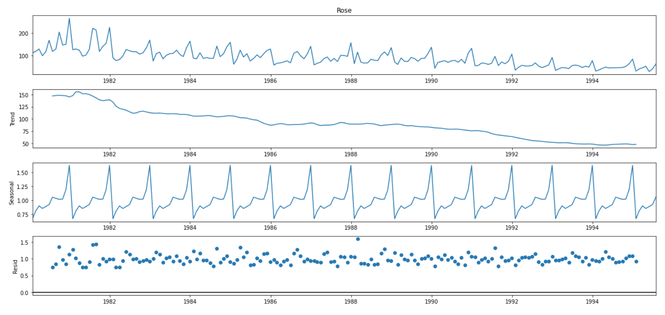

Sparkling

1. The first graph represents the original plot based on the data
2. The second graph shows us the trend. We can observe that across the time period there seems to be a cyclical trend. The sales declined and then rises again only to decline once again. Towards the end we can see that the sales are showing to be more or less constant
3. The third graph shows us the seasonality component. We can observe that there is a seasonal component in our dataset. As observed during EDA this could be attributed to the increase in sales of wine in the month of December
4. The fourth graph is a residual component showcasing the random variation in the series. We can observe that the values are spread out and there are outliers however there most of the values are close to each other indicating that there is not a lot of noise present in the data.

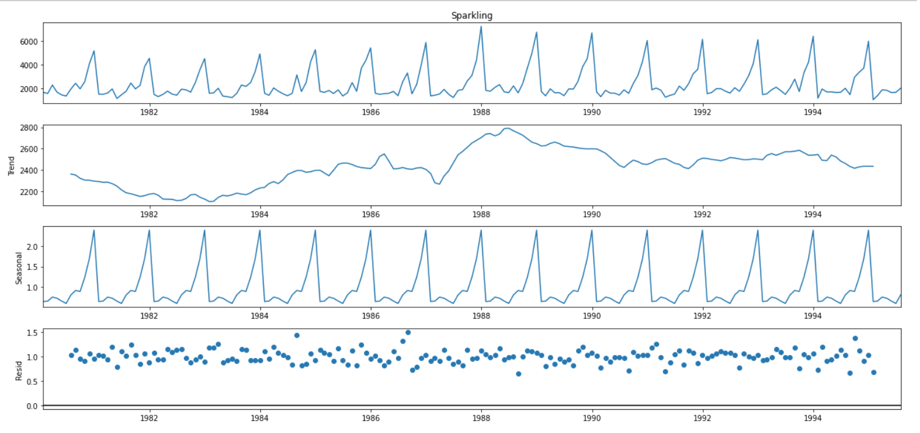

1. **Split the data into training and test. The test data should start in 1991.**

We split the data into Test and Train. For the train data we select the index as < 1991 in order to select all the value with less than 1991 and for test >= 1991 which would include all the values pertaining to 1991 and later up till 1995

We also print the shape of the train and test dataset

Train has 132 rows and test has 55

Rose

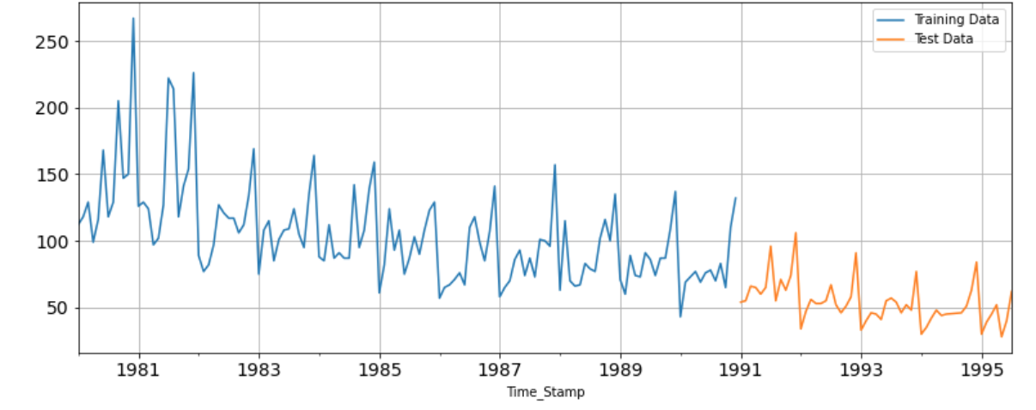

Sparkling

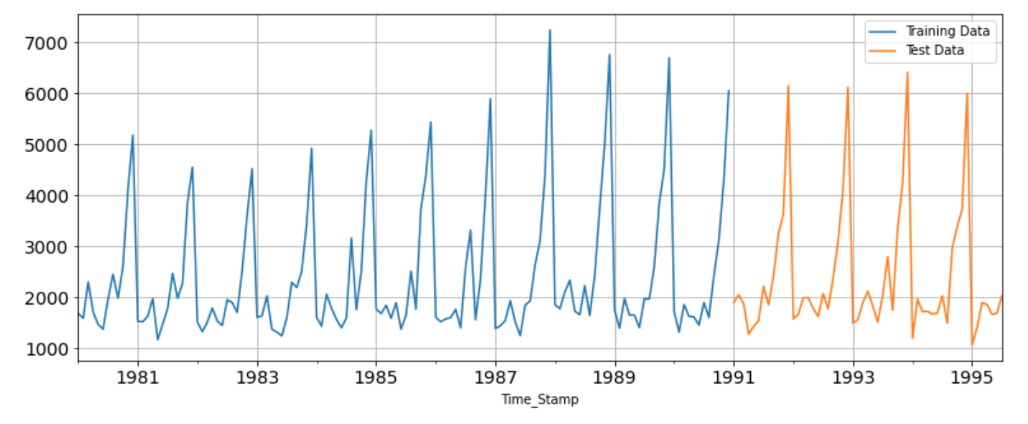

1. **Build various exponential smoothing models on the training data and evaluate the model using RMSE on the test data.  
   Other models such as regression, naïve forecast models, simple average models etc. should also be built on the training data and check the performance on the test data using RMSE.**

To build various models we follow the below steps and then check the performance using the RMSE values.

The **RMSE** is the square root of the variance of the residuals. It indicates the absolute fit of the model to the data–how close the observed data points are to the model's predicted values. The lower the value of the RMSE the better fit the data is.

1. Create a copy of the test and train variables
2. Create the extra variable (if applicable)
3. Import the relevant model
4. Fit it on the train and test data
5. Predict the values for both train and test data based on the model, refine parameters if required
6. Plot the train test data along with the fitted data together
7. Calculate the RMSE value

**Model 1: Linear Regression**: We include the time variable using the for loop in order to attach a numerical variable on the basis of the number of rows in order to be able to apply regression to the model as we cannot regress on time data. We get the following output after plotting the data.

Rose

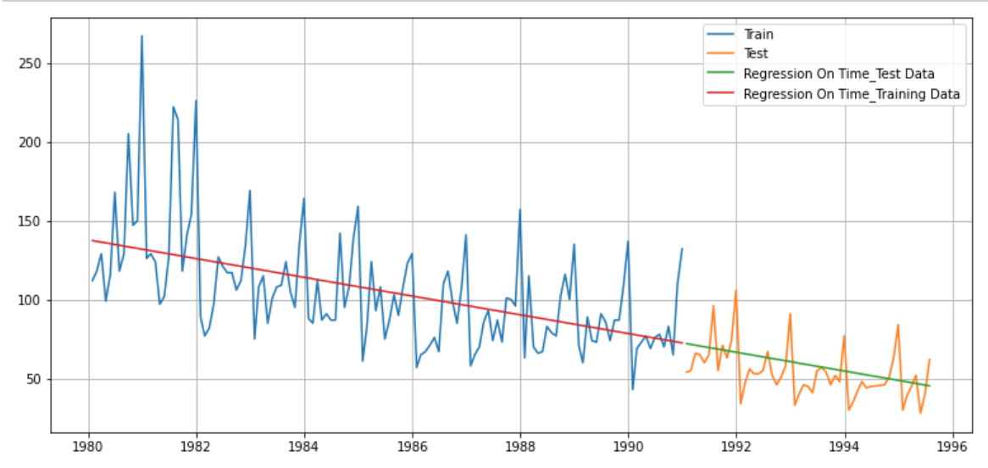

The RMSE value is for the Rose Test Data is RMSE is 15.269

Sparkling

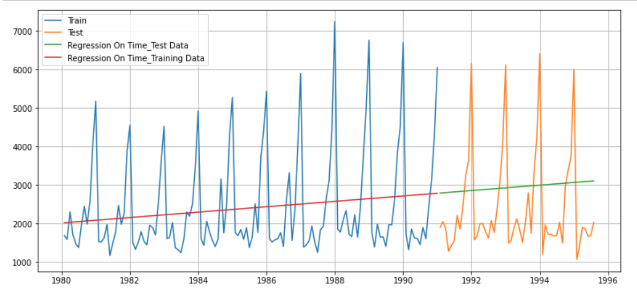

**RMSE value: 1279.322**

#### **Model 2: Naïve Approach:** In the Naïve approach we assume we say that the prediction for tomorrow is the same as today and the prediction for day after tomorrow is tomorrow and since the prediction of tomorrow is same as today, therefore the prediction for day after tomorrow is also today.

We follow the steps mentioned above. We create the variable naïve in the copy of the test and train dataset and use the array function to update the values from the last value in train dataset.

Rose

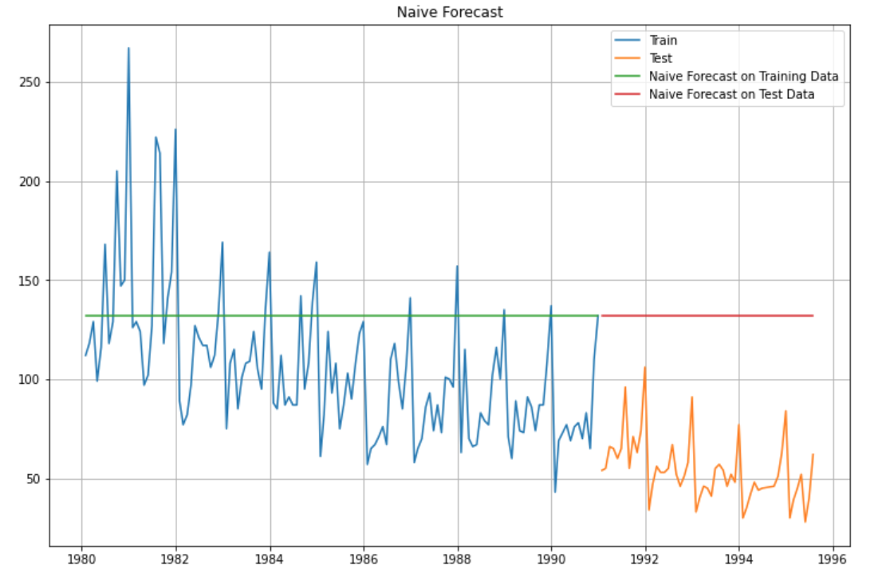

For RegressionOnTime forecast on the Test Data, RMSE is 79.719

Sparkling

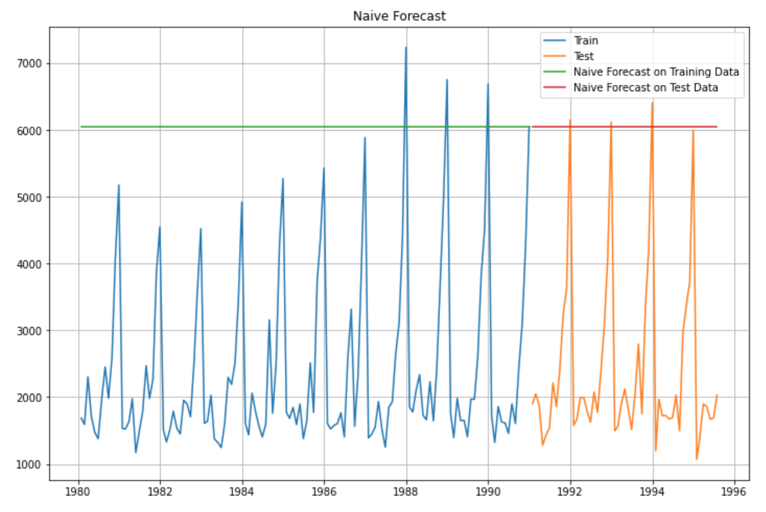

For RegressionOnTime forecast on the Test Data, RMSE is 3864.279

**Model 3: Simple Average:** As implied by the name here we use the mean value of the train data set to fit the model.

Rose

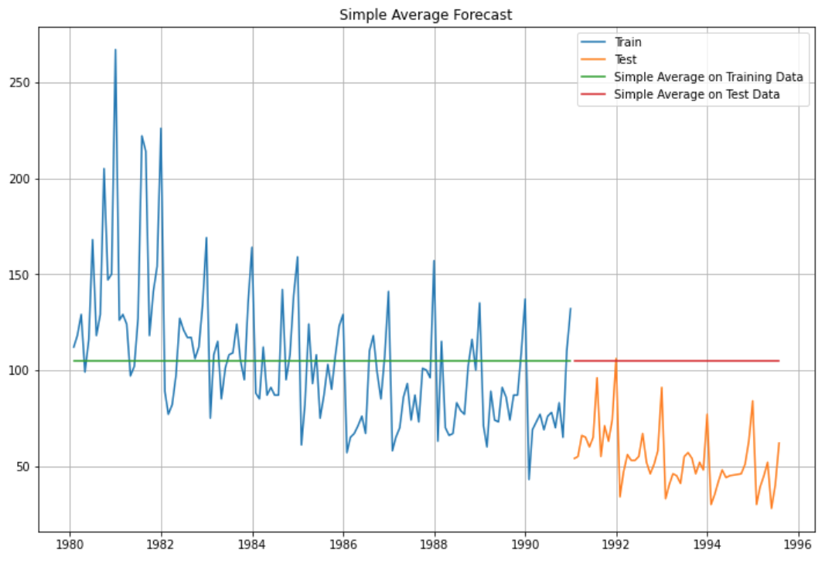

For Simple Average forecast on the Test Data, RMSE is 53.461

Sparkling

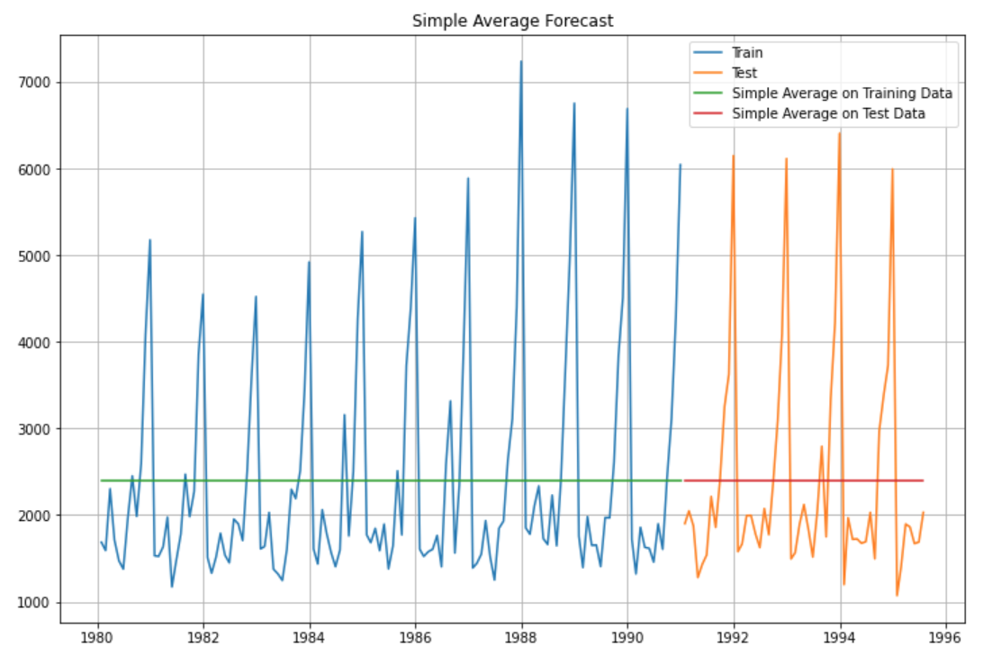

For Simple Average forecast on the Test Data, RMSE is 1275.082

Model 4: Moving Average: For the moving average we calculate the rolling mean for different windows in the data and use these values to fit the model on the data.

Rose

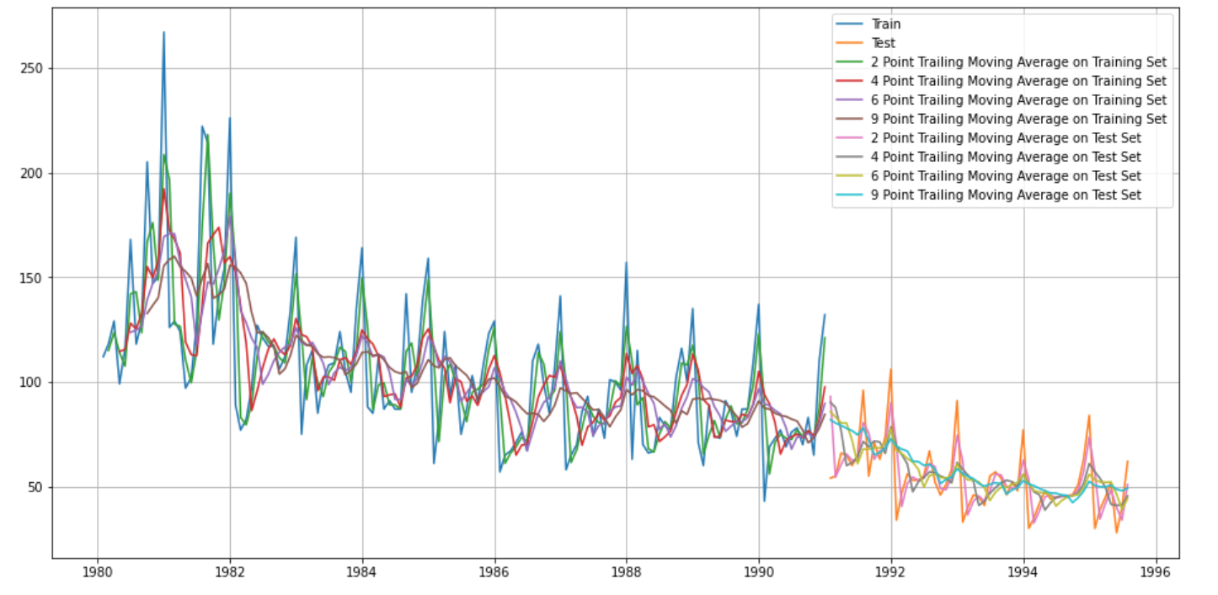

For 2 point Moving Average Model forecast on the Test Data, RMSE is 11.529 MAPE is 13.54

For 4 point Moving Average Model forecast on the Test Data, RMSE is 14.451 MAPE is 19.49

For 6 point Moving Average Model forecast on the Test Data, RMSE is 14.566 MAPE is 20.82

For 9 point Moving Average Model forecast on the Test Data, RMSE is 14.728 MAPE is 21.01

Sparkling

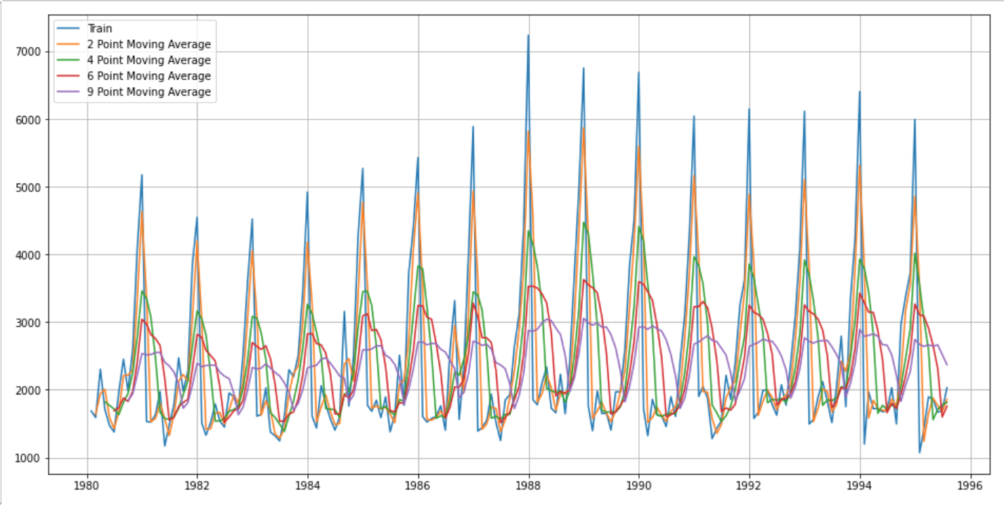

For 2 point Moving Average Model forecast on the Test Data, RMSE is 813.401 MAPE is 19.70

For 4 point Moving Average Model forecast on the Test Data, RMSE is 1156.590 MAPE is 35.96

For 6 point Moving Average Model forecast on the Test Data, RMSE is 1283.927 MAPE is 43.86

For 9 point Moving Average Model forecast on the Test Data, RMSE is 1346.278 MAPE is 46.86

**Model 5: Simple Exponential Smoothing (Taking log and without log of the data)**

**Rose**

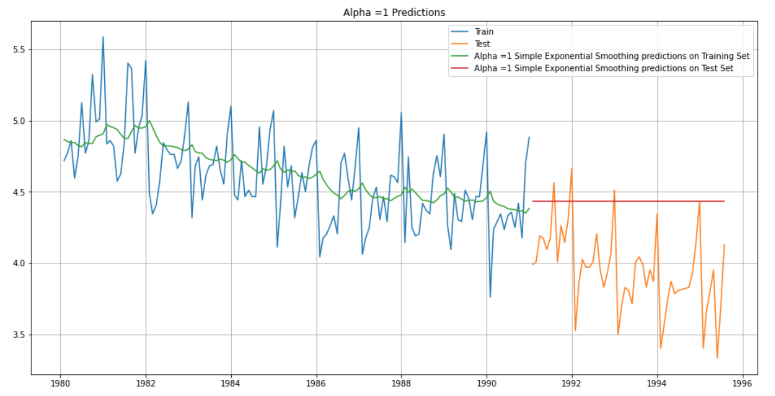

For Alpha =0.1 Simple Exponential Smoothing Model RMSE is 36.82

**Sparkling**

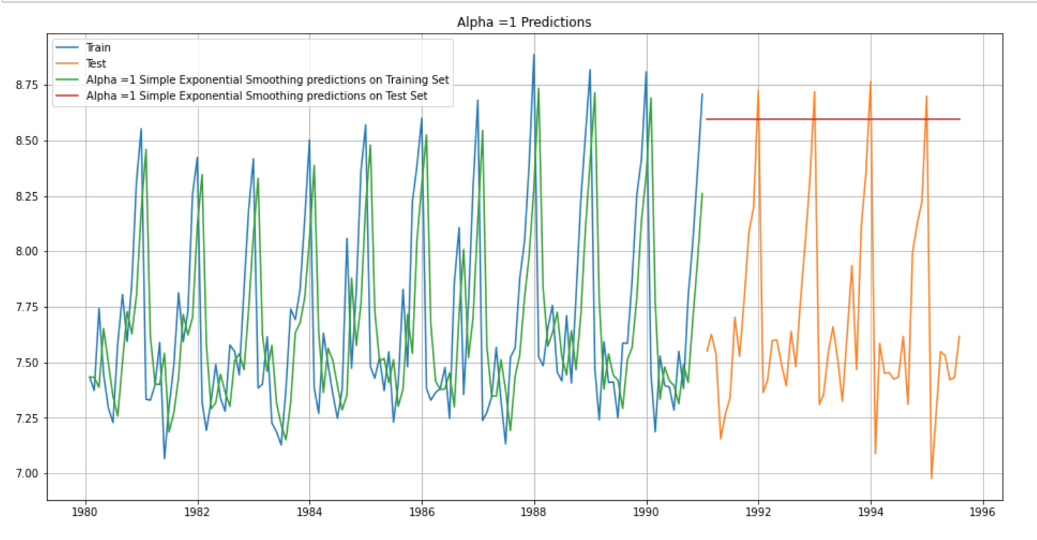

For Alpha =0.1 RMSE is 1375.39

**With log of the data**

Rose

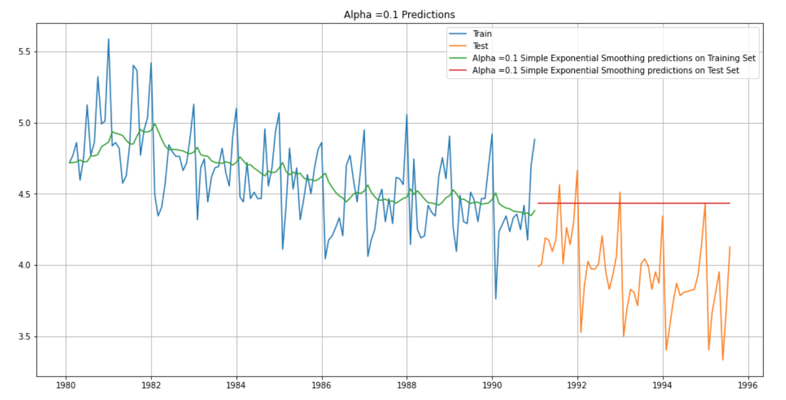

For Alpha =0.1 RMSE is 0.55

Sparkling

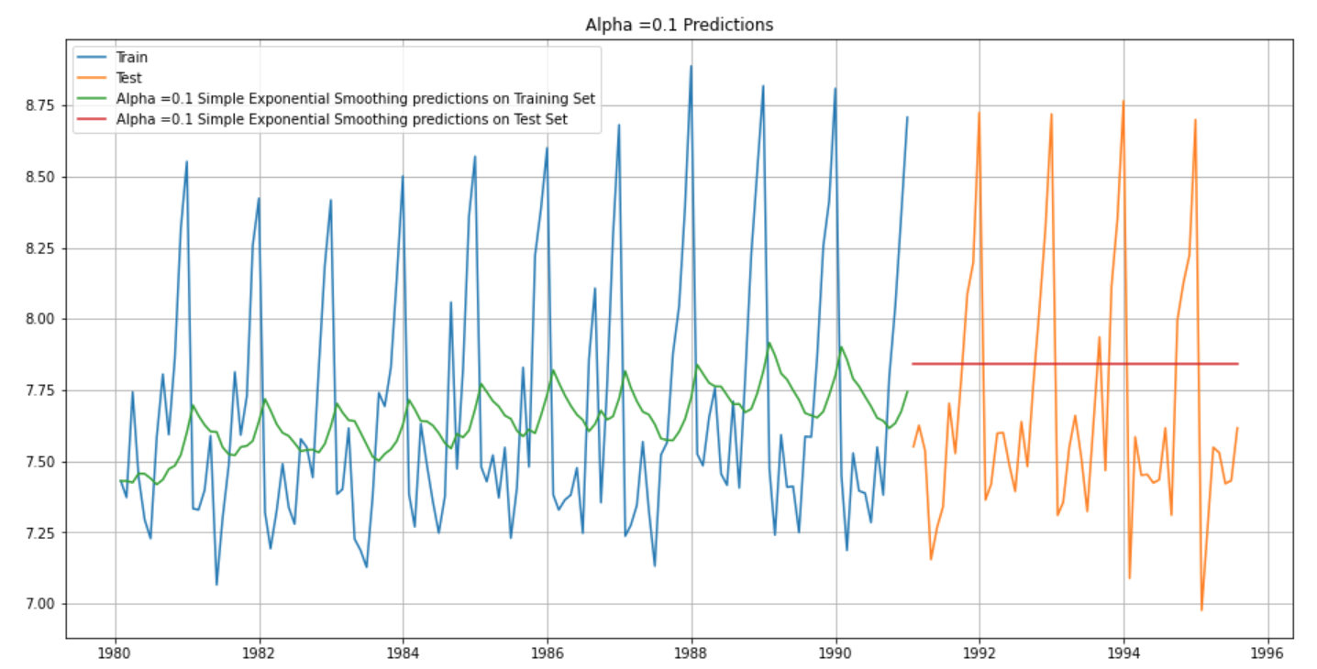

For Alpha =0.1 RMSE is 0.44

**Method 6: Double Exponential Smoothing :** For this model we estimate the values of the parameters alpha and beta which represent the smoothing and the trend component. For a combination of values of each we calculated the AIC and fitted the parameters with the lowest AIC value

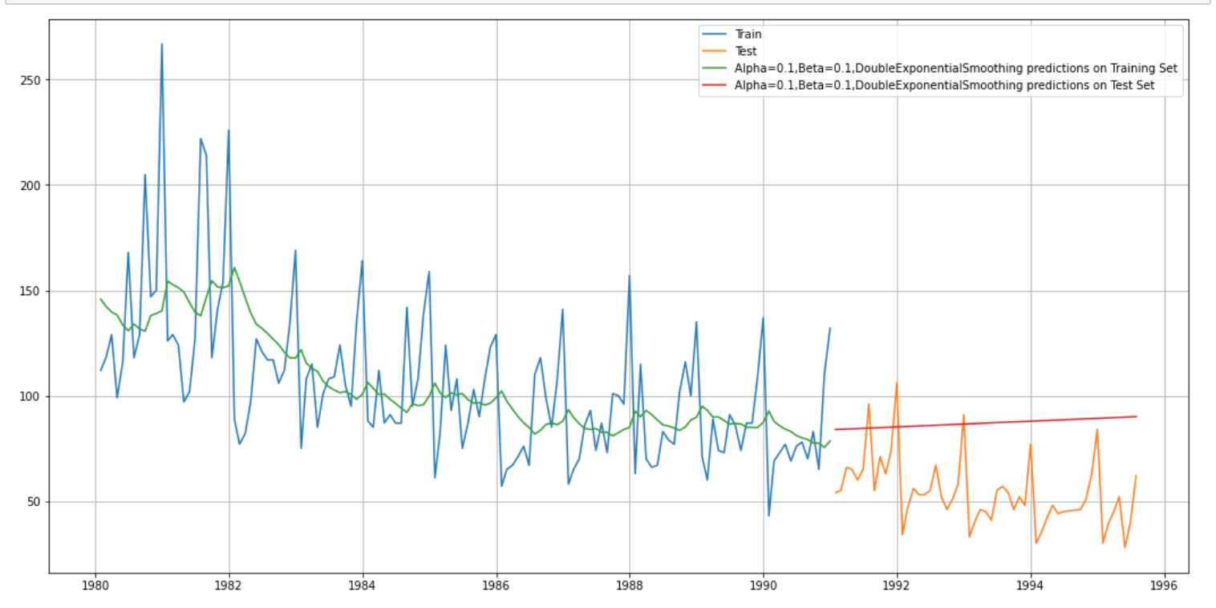

RMSE – 37.05

**Sparkling**

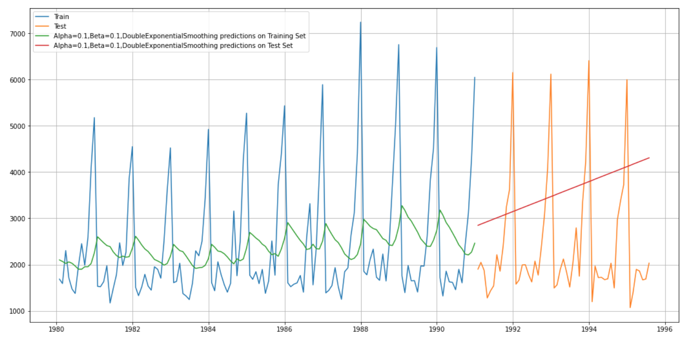

RMSE – 1779.42

**Method 7:** Triple Exponential Smoothing: For this model we estimate the values of the parameters alpha, beta and gamma, which represent the smoothing, the trend and the seasonality component. For a combination of values of each we calculated the AIC and fitted the parameters with the lowest AIC value

**Rose**

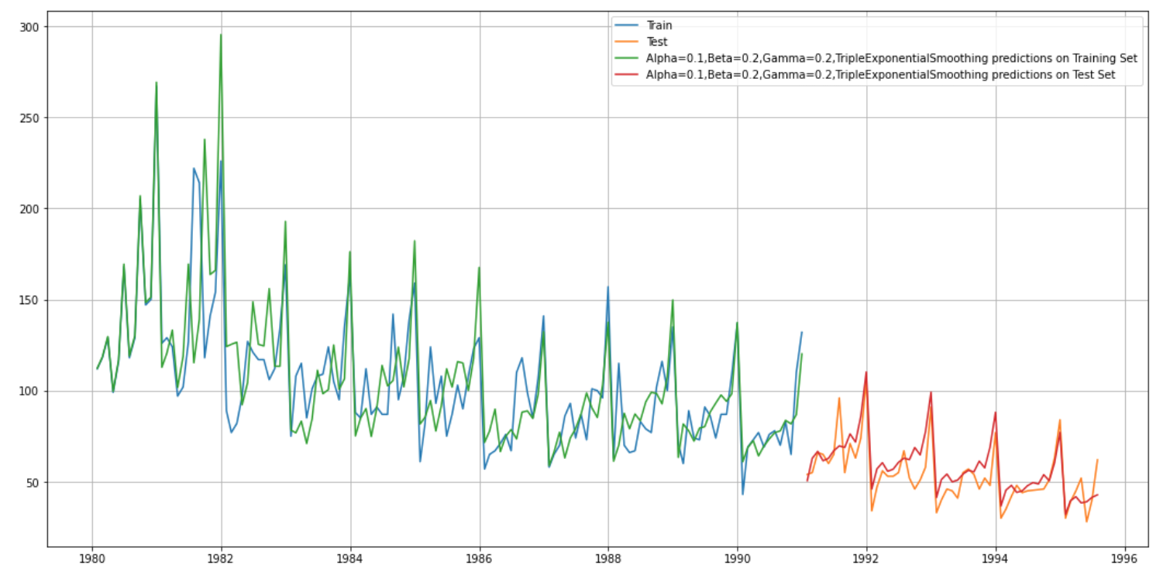

RMSE – 12.79

**Sparkling**

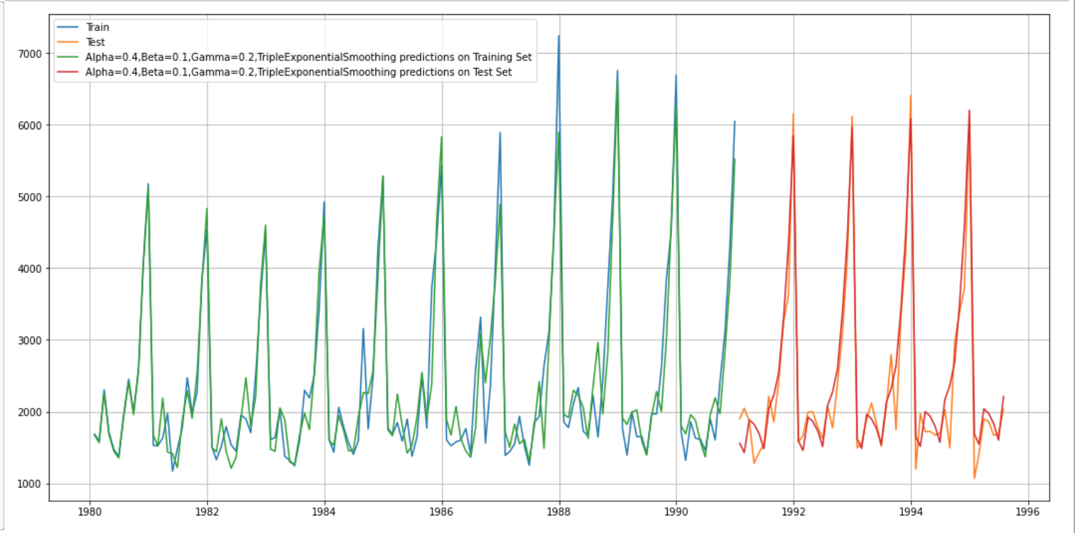

RMSE – 579.60

1. **Check for the stationarity of the data on which the model is being built on using appropriate statistical tests and also mention the hypothesis for the statistical test. If the data is found to be non-stationary, take appropriate steps to make it stationary. Check the new data for stationarity and comment.  
   Note: Stationarity should be checked at alpha = 0.05.**

To check for stationary we will develop the following hypothesis:

H0 : The series is non stationary

H1: The series is stationary

We will use the Dicky Fuller test to check for stationarity. We import adfuller from the statsmodels. We define a function to calculate the rolling statistics and plot the same and run the test to get the value of the test statistics and p value.

Rose

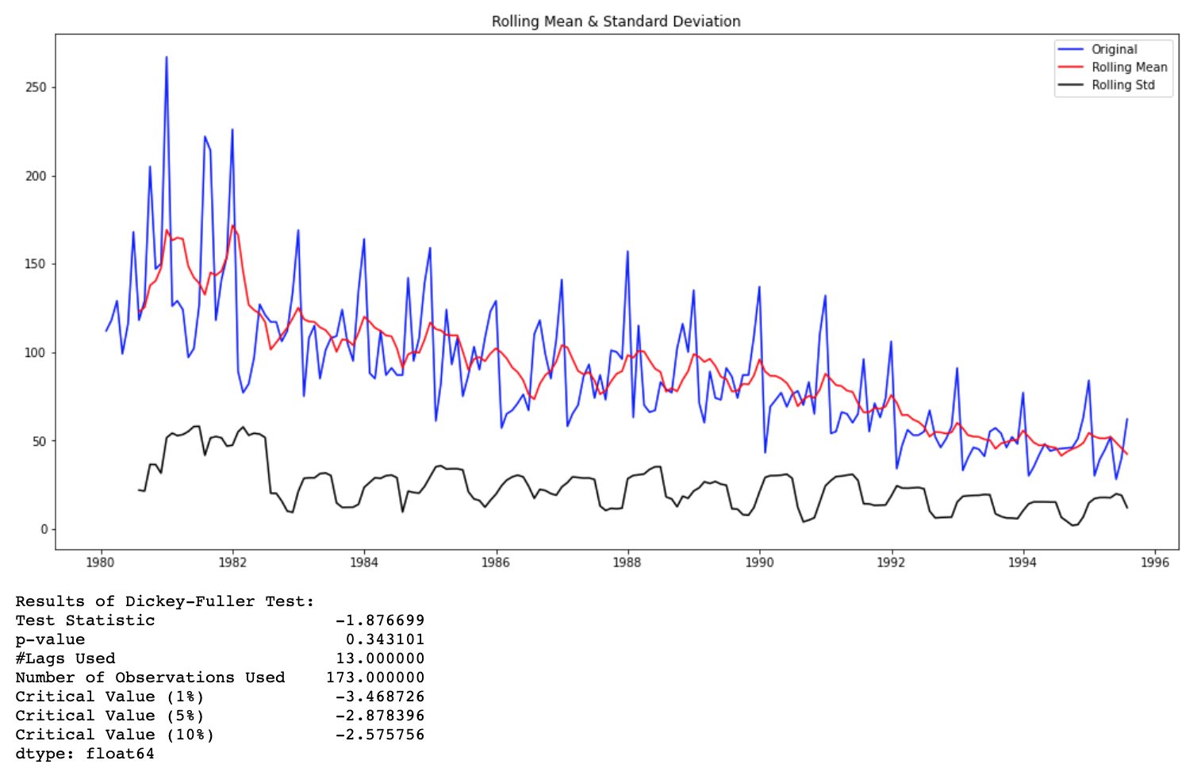

At a significance level of 5% we see that the series is non stationary as the p value is greater than 0.05

Let us take a difference of order 1 and check whether the Time Series is stationary or not.

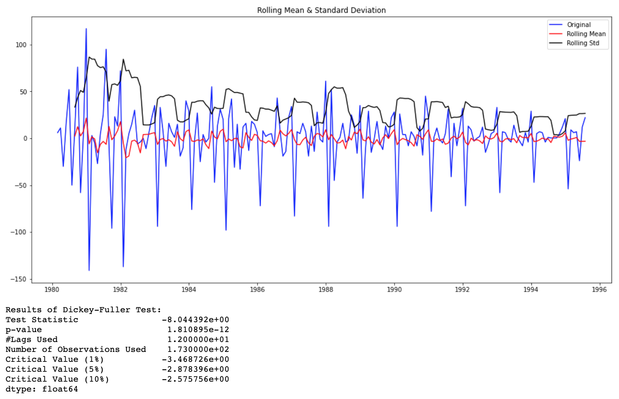

We see that after 1 degree of differentiation at alpha=0.05 the series is stationery

Sparkling

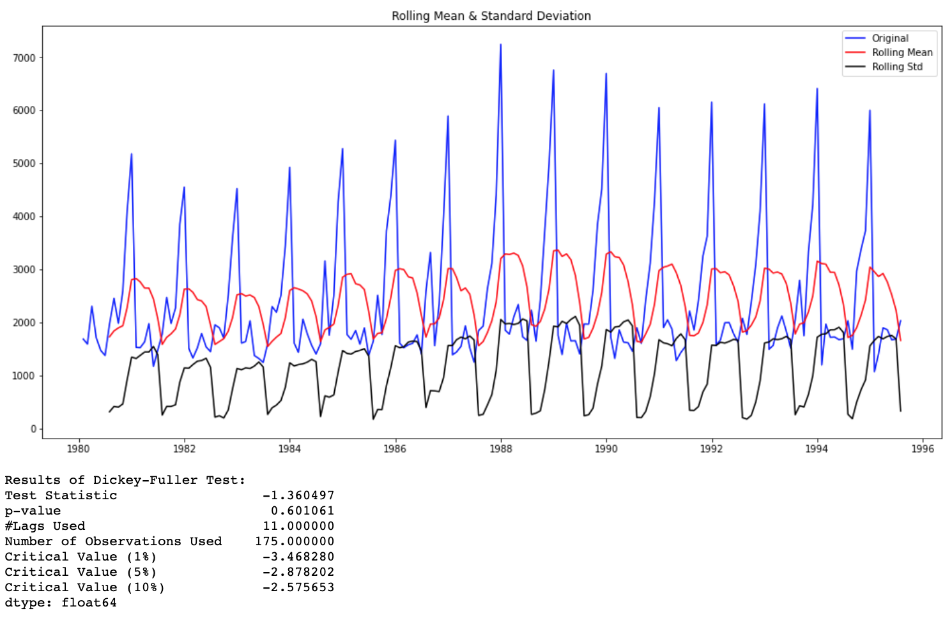

At a significance level of 5% we see that the series is non stationary as the p value is greater than 0.05

Let us take a difference of order 1 and check whether the Time Series is stationary or not.

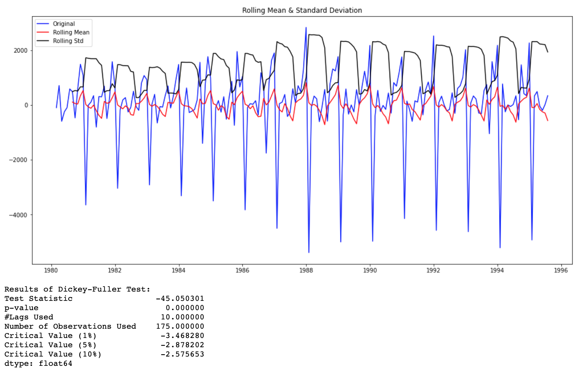

We see that after 1 degree of differentiation at alpha=0.05 the series is stationery

1. **Build an automated version of the ARIMA/SARIMA model in which the parameters are selected using the lowest Akaike Information Criteria (AIC) on the training data and evaluate this model on the test data using RMSE.**

We will build an ARIMA model and calculate AIC values to for a combination of different parameter values of p and q. We will keep the value of d as 1 as we need to take a difference of the series to make it stationary.

On calculating the AIC we get the following output –

Rose

|  |  |
| --- | --- |
| Rose | Sparkling |
|  |  |

Based on the lowest AIC values we use the corresponding parameter values and obtain the following result

For Rose – (0,1,2) and for Sparkling (2,1,2)

RMSE for Rose - 15.619658933558222

RMSE for Sparkling - 1373.9193171271997

1. **Build ARIMA/SARIMA models based on the cut-off points of ACF and PACF on the training data and evaluate this model on the test data using RMSE.**

**ACF** is an (complete) auto-correlation function which gives us values of auto-correlation of any series with its lagged values

**PACF** or the partial autocorrelation function gives the partial correlation of a stationary time series with its own lagged values, regressed the values of the time series at all shorter lags

Rose: Based on the ACF and PACF plot we can see the pdq values are p=1 and q=1 respectively. This is because we can see a significant change in the order at lag 1. We will consider d=1 as we have considered one order of difference

We then build the Arima models with the parameters and the result is an RMSE of 15.73

Sparkling: Based on the ACF and PACF plot we can see the p and q values are p=2 and q=1 respectively. This is because we can see a significant change in order at lag 2 in the ACF plot and lag 1 in the PACF plot. We consider d=1 as we have considered one order of difference.

We then build the Arima models with the parameters and the result is an RMSE of 1418.21

1. **Build a table with all the models built along with their corresponding parameters and the respective RMSE values on the test data.**

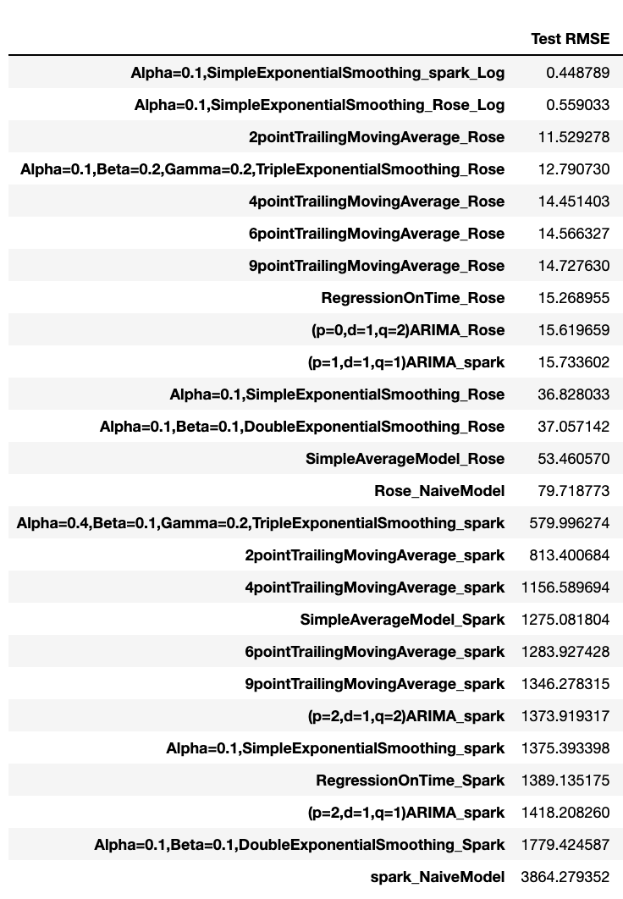

1. **Based on the model-building exercise, build the most optimum model(s) on the complete data and predict 12 months into the future with appropriate confidence intervals/bands.**

Based on the RMSE values we can see that the lowest RMSE values are for Simple Exponential smoothing model wherein we take the log of the data for both the data sets.

However, since the RMSE is so low we can look at some other models as well. This first few models have around the same RMSE therefore we will also forecast values for the ARIMA models for both Sparkling and Rose dataset.

We initially, fit the model to the entire dataset and calculate the RMSE values. We then go on to forecast for the following 12 months and plot the confidence intervals as well at 95%.

Exponential Model

Rose

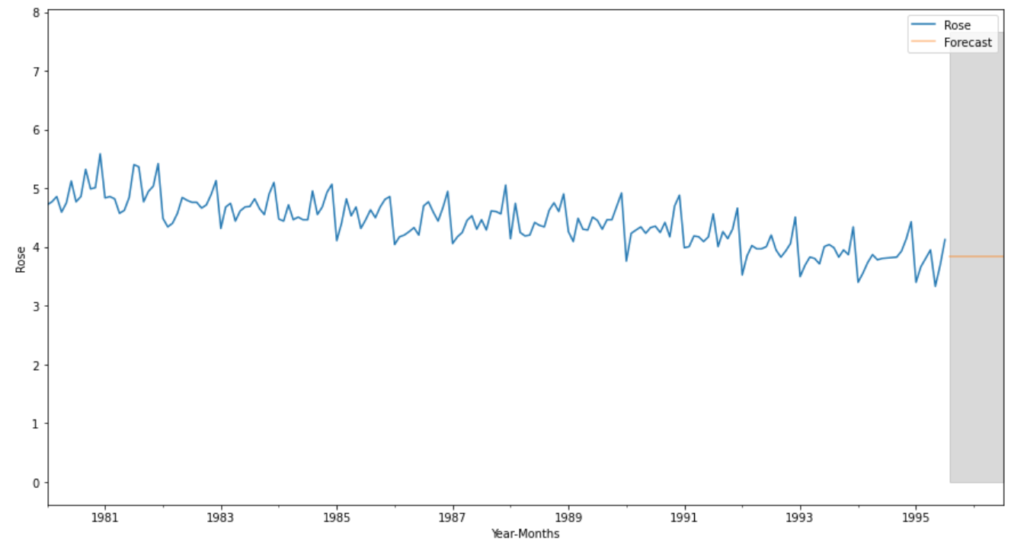

Sparkling

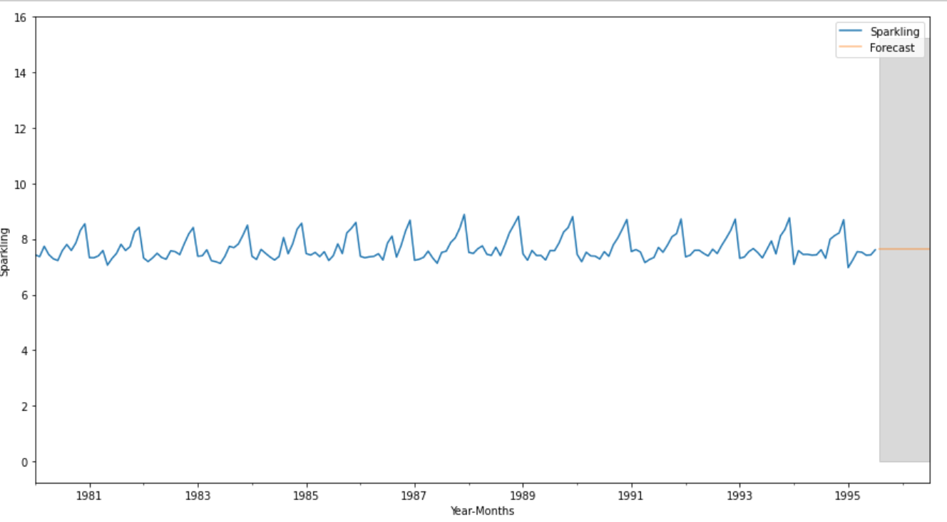

ARIMA

Rose

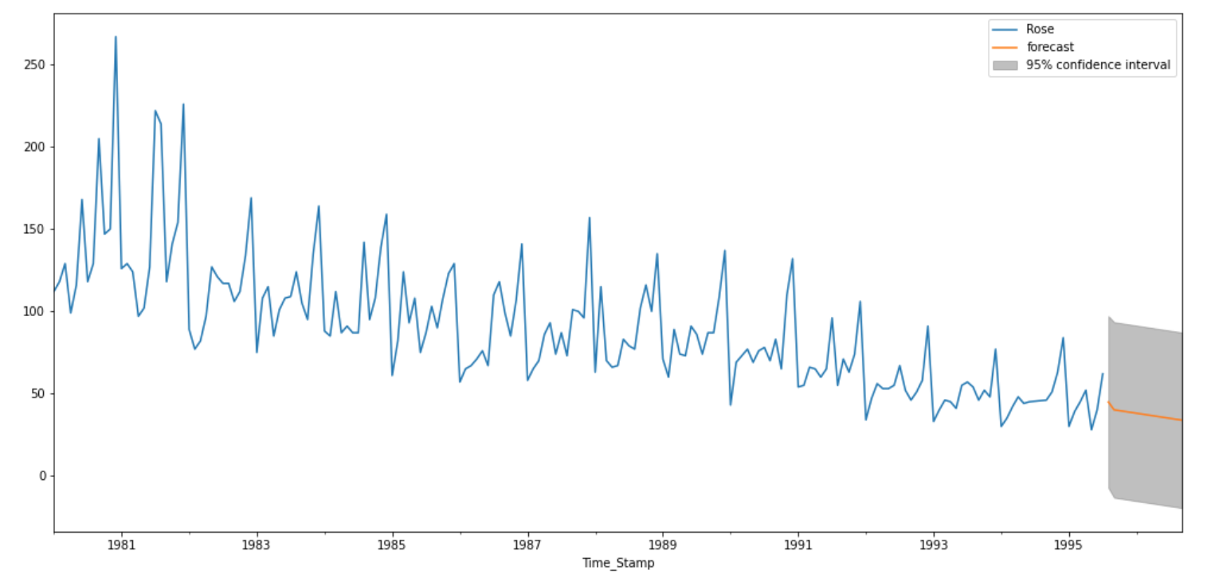

Sparkling

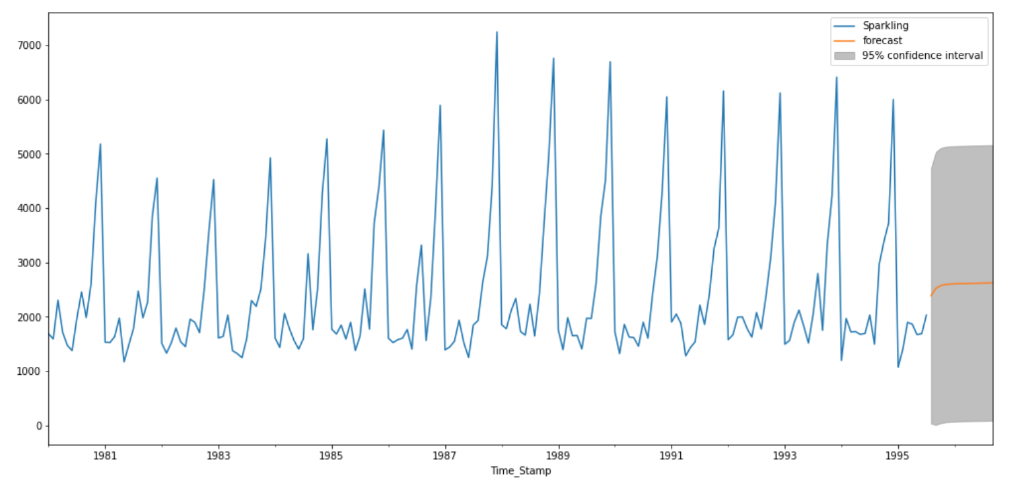

Based on the forecast and even at 95% confidence intervals, for the both models we can observe that the values can have a very wide range

1. **Comment on the model thus built and report your findings and suggest the measures that the company should be taking for future sales.**

Based on both the models we can observe the following:

Rose: As per the exponential model the sale is forecasted to be more constant as opposed to the declining trend observed in the dataset. Similarly as per the ARIMA model, the forecast for Rose sales is expected to continue declining.

ABC Estate Wines need to investigate the reason for the constant decline over the years. This could be due to a change in taste and preferences of the customers or any change in price. The company was identify the factors leading to this decline and take action in order to make a call to either continue with this product or replace it completely. They could also consider launching some offers during peak period such as December in order to increase sales and invest in marketing and research and development to enhance the Rose brand try to increase sales

Sparkling: The sparkling wine has had a more consistent performance across the years as opposed to Rose wine. As per the simple exponential model the sales are expected to be constant for the next 12 months. As per the ARIMA model there seems to very slight increasing trend for the next 12 months.

From the dataset we can observe that between the two wines Sparkling wine is the product that is doing better in the market and performing rather consistently. ABC Estate wines can take advantage of this slight upward trend and attempt to speed it up more by investing in marketing or tying up with relevant brands to make exciting offers during the peak periods which are towards the end of the year. ABC Estate wines should also explore the possibility of increasing sales in non-peak periods by identifying consumer behaviour and consumer spending patterns which would definitely benefit them in the long run